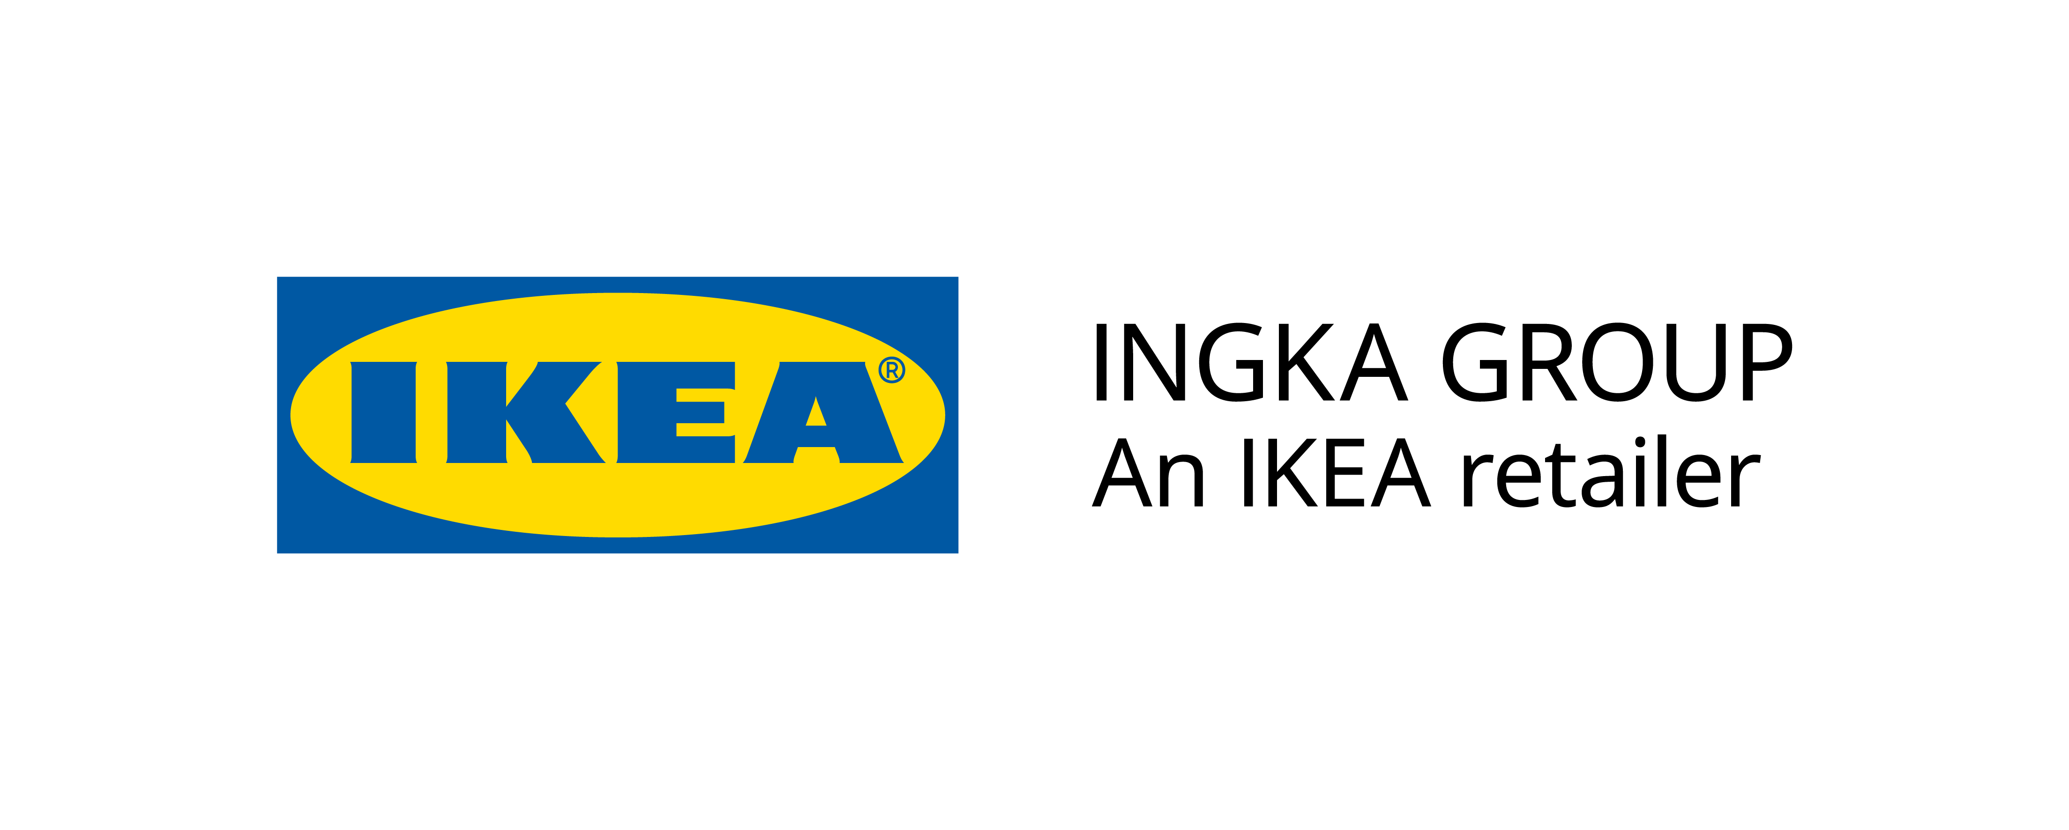

QUESTIONNAIRE TO SUBMIT IE REAL ESTATE COMPETITION III EDITION
IN COLLABORATION WITH IKEA INGKA GROUP

Q1. (300 words maximum + spaces)

How can companies use smart design to both cater to coworkers’ needs and build spaces where they want to be in a post-pandemic world where habits and expectations have changed?

Q2. (300 words maximum + spaces)

How can global companies like Ingka Group satisfy changing expectations in the workplace while also considering the impact on the environment?

Q3. (300 words maximum + spaces)

What makes a sustainable workplace?

Q4. (300 words maximum + spaces)

Based on the assumption that the workspace is all about community, what can be done to ensure that today’s workspaces meet people’s needs and serve as more than just walls?

***IMPORTANT INFORMATION***
Submissions must be directly sent to Victor Aleñar, Senior Manager, Global Recruitment Team, IE University Email: victor.alenar@ie.edu

